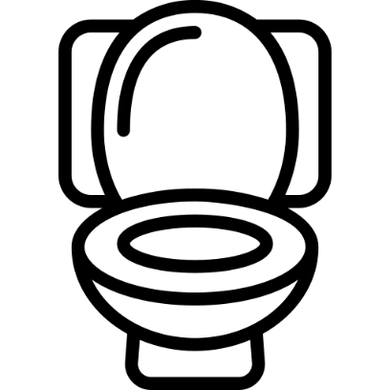
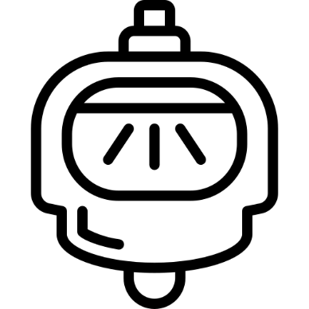
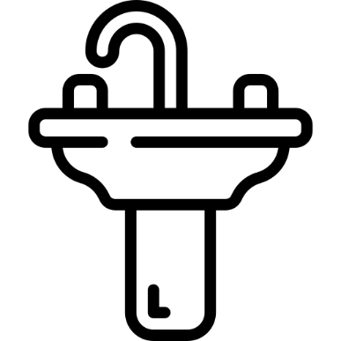
Icons made by Smashicons from www.flaticon.com
ALL GENDERS WELCOME
UNISEX TOILETTE

Gender

